- We expect the Monetary Policy Committee will keep Bank Rate at 5% at its next meeting on September 19. The clear message from the August meeting was that back-to-back cuts were unlikely. None of the data published since then warrants a change of approach.
- The MPC will also set the pace of quantitative tightening over the next 12 months. We expect the MPC will reduce the stock of gilts held in the Asset Purchase Facility by £100bn, the same pace as the past year. But the high level of redemptions due this year means that the MPC might opt to increase the pace of QT by £15bn-£20bn so the year-to-year profile for gilt sales is more stable.
At the August meeting of the Bank of England's Monetary Policy Committee, the split between the doves and the hawks widened. Five members voted to cut Bank Rate by 25bps, arguing that inflation is likely to undershoot the 2% target in two years' time, so policy should be loosened. But the other four members argued that upside surprises for services inflation and GDP growth suggested that underlying inflation pressures remained strong, and it was too soon to cut rates.
In the August policy statement, the MPC also tweaked its language around future decisions. In the minutes of previous meetings, the committee had made specific reference to monitoring the tightness of labour market conditions, wage growth, and services inflation. The August minutes didn't refer to these indicators, instead emphasising the MPC will make a broader judgement on the strength of inflation persistence. This continued the move away from data-dependence and offers both doves and hawks more flexibility.
The September decision hinges on whether the dovish group feels the situation is sufficiently urgent to warrant cutting again. We think this is unlikely. In Governor Andrew Bailey's opening remarks at the August press conference, he said: "we need to put the period of high inflation firmly behind us and we need to be careful not to cut rates too much or too quickly". In a similar vein, the minutes suggested that for some of those who voted to cut, the decision was finely balanced. We think this messaging is consistent with a gradual rate cutting cycle, with a clear warning that a second successive cut in September was unlikely if data published in the intervening period was broadly in line with the BoE's baseline forecast.
Chart 1: Underlying inflationary pressures continue to gradually fade
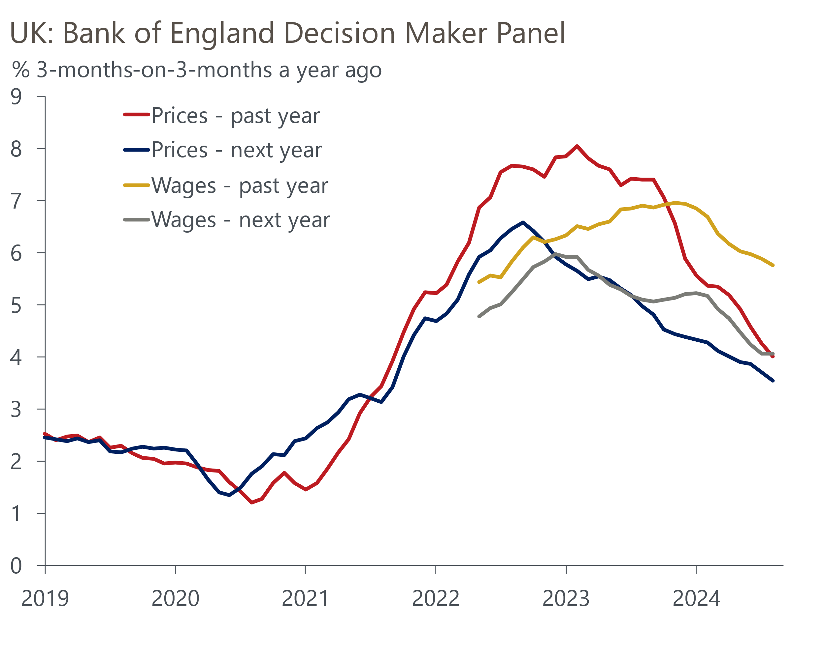
Source: Haver Analytics

Services inflation came in 0.4ppts below the BoE staff forecast in July. But that series has been very noisy lately, particularly due to volatility in the hotels category, and that undershoot followed a succession of overshoots. If we also factor in the move away from data dependence in favour of a more forward-looking approach, we doubt July's inflation data would have had much impact on the MPC's thinking. The August data will be published on September 18, the morning the MPC meets to vote.
Other data have continued to tell a similar story to previous months. Private sector regular pay growth slowed to 4.9% in the three months to July. This was the weakest growth for more than two years, though the recent slowdown has been exaggerated by base effects and July's outturn was still well above the 3%-3.5% pace that the MPC would consider consistent with achieving the inflation target on a sustained basis in the medium-term. It was a similar story from the BoE's Decision Maker Panel for August, with responses on past and future pay growth and selling prices continuing to fall on a three-months-on-three-months a year ago basis, but relatively slowly (Chart 1).
We think there's a good chance that those who have been voting for rate cuts for several months – in particular arch-dove Swati Dhingra – will vote for another cut. But the remaining members are likely to be content to sit back and reassess the situation in November, a meeting at which the MPC will update its forecasts to incorporate the impact of the Budget. We think that fiscal event will be the factor most likely to push the MPC off the gradual loosening path that it advocated in August.
The September meeting will be new member Professor Alan Taylor's first vote. Professor Taylor has replaced Jonathan Haskel, who was one of the more hawkish members of the committee. As is typically the case with new appointees, particularly those from academia, there's scant evidence of Taylor's recent views on monetary policy in the public domain. But new members typically vote with the majority while they find their feet. On balance, we expect the MPC to vote 8-1 to hold Bank Rate at 5%, with Dhingra voting for a 25bps cut.

The vote on the pace of QT could be the more important one
The MPC will also vote on the pace of quantitative tightening at the September meeting. The BoE began to run down the stock of gilts held in its Asset Purchase Facility in late-2022, via a combination of redemptions and gilt sales. In 2022-2023, it reduced the stock of gilts held by £80bn, while also selling its entire £20bn holding of corporate bonds. From October 2023 to September 2024, it will reduce its gilt holdings by £100bn, with a 50/50 split between redemptions and sales (Chart 2).
Chart 2: Higher redemptions means much lower gilt sales, if the MPC maintains the current pace of QT
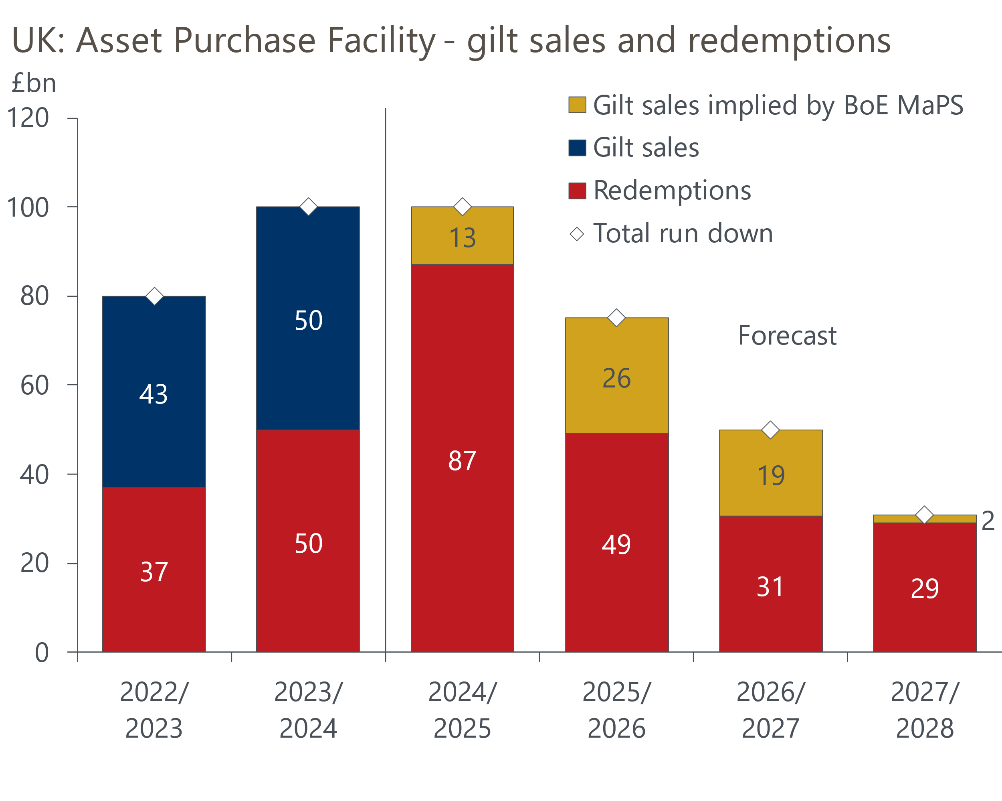
Sources: Oxford Economics calculations using data from Haver Analytics & Bank of England
The August Monetary Policy Report contained a box that concluded the impact of QT on gilt yields and the real economy had been small. The MPC also made clear it sees no conflict between cutting Bank Rate and continuing with QT. So QT will continue – the only question is around the pace.
Last month's BoE Market Participants Survey (MaPS) reported a firm consensus among market participants that the MPC would again vote to reduce the stock of gilts held in the APF by £100bn over the year from October. Our baseline forecast also assumes another £100bn cut, reducing the stock of gilts held in the APF in September 2025 to £558bn.
However, £87bn of redemptions are due over the next year, so this would reduce the value of gilt sales to just £13bn, from £50bn last year. The MaPS suggests that market participants expect the pace of QT will fall from 2025-2026. But given that the value of redemptions will drop sharply, this implies that the level of gilt sales will then increase again, to £26bn in 2025-2026. The MPC might decide that this year's fall in gilt sales is too steep, and that it's undesirable to have the level of gilt sales fluctuate so much from one year to another. So the risks to our forecast are skewed towards the pace of QT being increased from October, with a total fall in gilt holdings of £115bn-£120bn being a plausible alternative scenario.
The consensus view that the pace of QT will slow from 2025 partly reflects the idea that, unless offset by other BoE facilities, the current pace of APF rundown may soon leave banks with inadequate reserves at the BoE. This could add upward pressure and volatility to short-term interest rates. But we think this concern is misplaced because the BoE can use a major expansion of short-term repos as the counterpart to a persistently high level of bank reserves.
If we are right, and the BoE plans to continue the APF run down at its current pace until all the gilts have been sold, this meeting represents a good opportunity to outline their medium-term plans to markets.
Should the MPC change the pace of QT or provide guidance on likely future changes, it could have implications for fiscal policy. The debt rule inherited from the previous government includes the impact of the cost of the Treasury indemnifying the BoE for losses when it sells gilts held in the APF. We've consistently argued that this is problematic, leaving fiscal policy open to the heavy influence of one-off effects that are outside of the government's direct control, with a very uneven profile from year-to-year.
We think the Chancellor will address this anomaly in the Budget and exclude the impact of APF losses from the fiscal rules. This change would also increase her fiscal headroom considerably. But if Rachel Reeves does not make this tweak, the OBR's assumption for the pace of QT will remain central to its assessment of the government's chances of complying with its fiscal rules. Currently, the OBR assumes that QT will continue at its current pace and end in 2032-2033. But if the MPC announces any changes to QT that would warrant the OBR revisiting this assumption, it could materially affect the Chancellor's fiscal headroom.

